Aim:- To enhance the given degraded images using histogram equalization and histogram matching, and compare their effects on image contrast and clarity.
Theory :-
Theory
Histogram-based image enhancement is a technique used in digital image processing to improve the contrast, brightness, and overall visual quality of degraded images. A histogram represents the frequency of different gray-level or pixel-intensity values present in an image, usually ranging from 0 to 255 for an 8-bit grayscale image. When the intensity values are concentrated in a small range, the image may appear too dark, too bright, or have poor contrast.
Histogram Equalization improves contrast by redistributing the gray-level intensities over a wider range. It uses the cumulative distribution function (CDF) of the image histogram to transform the original intensity values. This can make hidden details more visible and improve the overall contrast of an image. However, because the transformation is automatic, it may sometimes produce excessive contrast or amplify unwanted details and noise.
Histogram Matching, also called histogram specification, is a technique in which the histogram of a source image is modified to match the histogram of a selected reference image. Instead of automatically spreading the intensity values, it creates a mapping between the cumulative distributions of the source and reference images. This provides greater control over the final brightness and contrast of the enhanced image.
In this experiment, the same set of degraded images from OPE7 is processed using both techniques. For each image, the original image, histogram-equalized image, and histogram-matched image are compared visually along with their histograms. Histogram equalization is expected to provide general contrast enhancement, while histogram matching can produce an intensity distribution closer to the selected reference image.
The effectiveness of both methods depends on the original degradation and intensity distribution of each image. Therefore, one technique may produce better visual results for one image while the other may be more suitable for another. By comparing the contrast, brightness, clarity, details, and histogram distribution, the better enhancement technique can be determined for each degraded image.
Image 1 — Histogram Equalization and Histogram Matching
Explanation
Explanation
The program performs Histogram Equalization and Histogram Matching on the degraded image ex1_1.png and compares the original, equalized, and matched images using their visual appearance, histograms, mean intensity, and standard deviation.
1. Importing Libraries
import numpy as np
import pandas as pd
import matplotlib.pyplot as plt
Three libraries are imported. NumPy is used for numerical calculations and image-array operations, Pandas is used to create the lookup table for histogram matching, and Matplotlib is used to read, display, and plot the images and their histograms.
2. Reading and Converting the Image
src_image = plt.imread("ex1_1.png")
The degraded image ex1_1.png is loaded into the program. If the image is RGB or contains multiple channels, the following code converts it into grayscale:
if src_image.ndim == 3:
src_image = np.dot(src_image[..., :3], [0.2989, 0.5870, 0.1140])
The RGB channels are combined using standard luminance weights. The green channel has the highest contribution because the human eye is more sensitive to green.
if src_image.max() <= 1.0:
src_image = src_image * 255
Some images are loaded with pixel values between 0 and 1. This condition converts them to the standard 0–255 range.
src_image = src_image.astype(np.uint8)
Finally, the image is converted to 8-bit unsigned integer format, where each pixel has an intensity value from 0 to 255.

3. Histogram Equalization
hist, bins = np.histogram(src_image.flatten(), 256, [0, 256])
The histogram of the original image is calculated using 256 intensity levels. flatten() converts the 2D image into a one-dimensional array of pixel values.
cdf = hist.cumsum()
The Cumulative Distribution Function (CDF) is calculated by cumulatively adding the histogram values.
cdf_normalized = (cdf - cdf.min()) * 255 / (cdf.max() - cdf.min())
The CDF is normalized to the range 0–255. This creates the transformation required for histogram equalization.
cdf_normalized = cdf_normalized.astype(np.uint8)
equalized_image = cdf_normalized[src_image]
Each original pixel intensity is replaced by its corresponding transformed intensity. The result is stored as equalized_image.
Therefore, this section spreads the intensity values and generally improves the global contrast and visibility of details.

4. Creating the Reference Image
np.random.seed(42)
reference_image = np.random.normal(loc=128, scale=50, size=(300, 300))
A reference image is generated using a Gaussian (normal) distribution.
Here:
- Mean = 128
- Standard deviation = 50
- Size =
The mean of 128 places the reference intensity distribution around the middle of the grayscale range, while the standard deviation of 50 controls how widely the intensity values are distributed.
reference_image = np.clip(reference_image, 0, 255).astype(np.uint8)
Since pixel values must remain between 0 and 255, np.clip() limits values outside this range. The image is then converted to uint8.
This generated image acts as the target/reference histogram for histogram matching.

5. Calculating Histograms for Matching
src_hist, _ = np.histogram(src_image.flatten(), 256, [0, 256])
ref_hist, _ = np.histogram(reference_image.flatten(), 256, [0, 256])
The histogram of both the source image and reference image is calculated.
- src_hist → histogram of degraded image.
- ref_hist → histogram of reference image.

6. Calculating CDFs
src_cdf = np.cumsum(src_hist).astype(np.float64)
src_cdf = src_cdf / src_cdf[-1]
The CDF of the source image is calculated and normalized between 0 and 1.
Similarly:
ref_cdf = np.cumsum(ref_hist).astype(np.float64)
ref_cdf = ref_cdf / ref_cdf[-1]
The CDF of the reference image is calculated and normalized.
The normalization allows the CDFs of both images to be compared directly.

7. Creating the Histogram Matching Mapping
mapping = pd.Series(index=np.arange(256), dtype=np.uint8)
ref_cdf_series = pd.Series(ref_cdf)
A lookup table called mapping is created for all 256 possible intensity values.
The following loop finds the closest matching intensity in the reference image:
for i in range(256):
diff = (ref_cdf_series - src_cdf[i]).abs()
mapping[i] = diff.idxmin()
For every source intensity i, the program calculates the difference between its CDF value and every value in the reference CDF.
diff.idxmin()
selects the reference intensity having the smallest difference.
Thus, the program creates a mapping such as:
This is the main step responsible for histogram matching.
mapping = mapping.values.astype(np.uint8)
matched_image = mapping[src_image]
The mapping is converted into an array, and every pixel in the original image is replaced by its corresponding mapped intensity.
The final result is stored in matched_image.

8. Displaying the Images
plt.figure(figsize=(15, 5))
A figure is created to display the three images side by side.
plt.subplot(1, 3, 1)
displays the original image.
plt.subplot(1, 3, 2)
displays the histogram-equalized image.
plt.subplot(1, 3, 3)
displays the histogram-matched image.
The use of:
cmap='gray', vmin=0, vmax=255
ensures that all three images are displayed as grayscale images using the same intensity range, making visual comparison easier.

9. Displaying Histograms
The second figure displays the histograms of all three images.
plt.hist(src_image.ravel(), bins=256, range=(0, 255))
shows the histogram of the original image.
plt.hist(equalized_image.ravel(), bins=256, range=(0, 255))
shows how histogram equalization changed the intensity distribution.
plt.hist(matched_image.ravel(), bins=256, range=(0, 255))
shows how the intensity distribution changed after histogram matching.
These histograms help us understand the reason behind the visual changes in the images.

10. Calculating Mean and Standard Deviation
Finally, the program calculates the mean and standard deviation for all three images:
print(f"Original : mean={src_image.mean():.1f} std={src_image.std():.1f}")
print(f"Equalized: mean={equalized_image.mean():.1f} std={equalized_image.std():.1f}")
print(f"Matched : mean={matched_image.mean():.1f} std={matched_image.std():.1f}")
The mean represents the average brightness of the image.
The standard deviation indicates how widely the pixel intensities are distributed around the mean and can be used as an indicator of contrast.
Generally:
- Higher standard deviation → wider intensity variation → potentially higher contrast.
- Lower standard deviation → narrower intensity variation → potentially lower contrast.
Code:-
import cv2
import numpy as np
import matplotlib.pyplot as plt
from skimage.exposure import match_histograms

# Read image in grayscale
src_image = cv2.imread("ex1_1.png", cv2.IMREAD_GRAYSCALE)

if src_image is None:
print("Image not found!")
exit()

# -------------------------
# Reference image for matching (Gaussian target, mean=128, std=50)
# -------------------------
np.random.seed(42)
reference_image = np.random.normal(loc=128, scale=50, size=(300, 300))
reference_image = np.clip(reference_image, 0, 255).astype(np.uint8)

# -------------------------
# Histogram Equalization
# -------------------------
equalized_image = cv2.equalizeHist(src_image)

# -------------------------
# Histogram Matching
# -------------------------
matched_image = match_histograms(src_image, reference_image)
matched_image = np.uint8(np.clip(matched_image, 0, 255))

# -------------------------
# Display Images
# -------------------------
plt.figure(figsize=(15, 5))

plt.subplot(1, 3, 1)
plt.imshow(src_image, cmap='gray', vmin=0, vmax=255)
plt.title("Original")
plt.axis('off')

plt.subplot(1, 3, 2)
plt.imshow(equalized_image, cmap='gray', vmin=0, vmax=255)
plt.title("Histogram Equalized")
plt.axis('off')

plt.subplot(1, 3, 3)
plt.imshow(matched_image, cmap='gray', vmin=0, vmax=255)
plt.title("Histogram Matched")
plt.axis('off')

plt.show()

# -------------------------
# Histograms
# -------------------------
plt.figure(figsize=(15, 4))

plt.subplot(1, 3, 1)
plt.hist(src_image.ravel(), bins=256, range=(0, 255))
plt.title("Original Histogram")

plt.subplot(1, 3, 2)
plt.hist(equalized_image.ravel(), bins=256, range=(0, 255))
plt.title("Equalized Histogram")

plt.subplot(1, 3, 3)
plt.hist(matched_image.ravel(), bins=256, range=(0, 255))
plt.title("Matched Histogram")

plt.show()

# -------------------------
# Stats
# -------------------------
print(f"Original : mean={src_image.mean():.1f} std={src_image.std():.1f}")
print(f"Equalized: mean={equalized_image.mean():.1f} std={equalized_image.std():.1f}")
print(f"Matched : mean={matched_image.mean():.1f} std={matched_image.std():.1f}")

Expected Output
After running the program, three enhanced images and their corresponding histograms will be displayed.
1. Original Image: The original degraded ex1_1.png image will be displayed in grayscale. It may appear dark, dull, or have low contrast depending on the original degradation.
2. Histogram Equalized Image: The equalized image is expected to show improved global contrast. Details in darker or brighter regions should become more visible, and the image should appear clearer. Its histogram should be spread over a wider intensity range compared with the original.
3. Histogram Matched Image: The matched image will have its intensity distribution adjusted according to the generated Gaussian reference histogram. The image is expected to have a more controlled brightness and contrast, with its histogram resembling the distribution of the reference image.
The program will also display the mean and standard deviation of the original, equalized, and matched images. The mean indicates the average brightness, while the standard deviation indicates the spread of intensity values and helps in comparing the contrast.
Overall, the expected result is that both techniques improve the visual quality of the degraded image, but the amount of improvement in contrast, brightness, and clarity may differ between histogram equalization and histogram matching.
Observation
After applying Histogram Equalization and Histogram Matching to the degraded image, a noticeable improvement in the visual quality of the image can be observed. The histogram equalized image shows increased global contrast because the pixel intensity values are redistributed over a wider range. As a result, details and edges that were less visible in the original degraded image become clearer. However, some regions may appear slightly over-enhanced, and existing noise can also become more noticeable.
The histogram matched image shows an intensity distribution closer to the selected Gaussian reference histogram. Compared with histogram equalization, the brightness and contrast are more controlled, giving the image a relatively smoother and more natural appearance. The histogram also follows the desired reference distribution rather than being uniformly distributed.
From the numerical results, changes in the mean indicate changes in average image brightness, while changes in standard deviation indicate changes in intensity spread and contrast. Overall, both methods improve the degraded image, but their effectiveness depends on the original image characteristics. Histogram Equalization is more effective when strong global contrast enhancement is required, whereas Histogram Matching is preferable when a specific and controlled intensity distribution is desired.
Output :-
Result:-
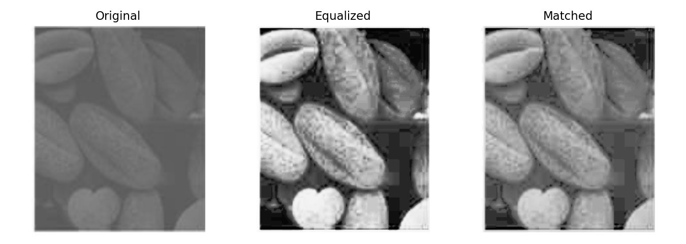

Histograms:-
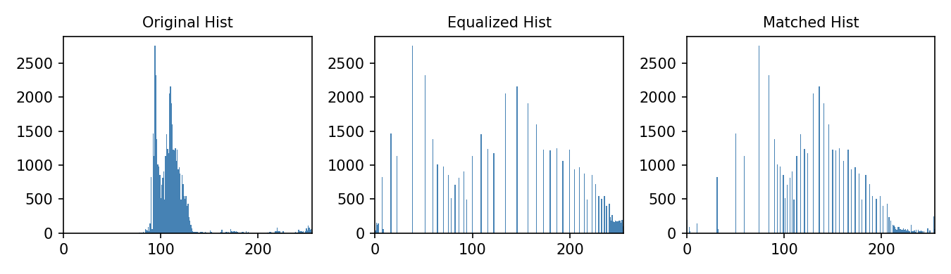
Image 2 — Circular Texture (Histogram Equalization + Matching):-
Explanation
This program applies Histogram Equalization and Histogram Matching to the degraded image ex1_2.png. It then displays the original and enhanced images, compares their histograms, and calculates the mean and standard deviation to analyze changes in brightness and contrast.
1. Importing Libraries
import numpy as np
import pandas as pd
import matplotlib.pyplot as plt
NumPy is used for numerical calculations and image processing, Pandas is used to create the intensity mapping table for histogram matching, and Matplotlib is used to read, display, and plot the images and histograms.
2. Reading and Converting the Image
src_image = plt.imread("ex1_2.png")
The degraded image ex1_2.png is loaded into the program.
if src_image.ndim == 3:
src_image = np.dot(src_image[..., :3], [0.2989, 0.5870, 0.1140])
If the image is RGB, it is converted into a grayscale image using weighted contributions from the red, green, and blue channels.
if src_image.max() <= 1.0:
src_image = src_image * 255
If the image contains pixel values between 0 and 1, they are converted to the standard 0–255 range.
src_image = src_image.astype(np.uint8)
The image is converted to 8-bit format so that each pixel has an intensity value from 0 to 255.

3. Histogram Equalization
hist, bins = np.histogram(src_image.flatten(), 256, [0, 256])
The histogram of ex1_2.png is calculated using 256 intensity levels.
cdf = hist.cumsum()
The cumulative distribution function (CDF) is calculated by cumulatively adding the histogram frequencies.
cdf_normalized = (cdf - cdf.min()) * 255 / (cdf.max() - cdf.min())
The CDF is normalized to the range 0–255 to create the transformation function.
cdf_normalized = cdf_normalized.astype(np.uint8)
equalized_image = cdf_normalized[src_image]
Each original intensity value is replaced by its corresponding transformed value. This produces the histogram equalized image.
The main purpose of this step is to increase the global contrast and make details more visible.

4. Creating the Reference Image
np.random.seed(42)
reference_image = np.random.normal(loc=128, scale=50, size=(300, 300))
A Gaussian-distributed reference image is generated with:
- Mean = 128
- Standard deviation = 50
- Size = 300 × 300
This reference image provides the target intensity distribution for histogram matching.
reference_image = np.clip(reference_image, 0, 255).astype(np.uint8)
The pixel values are restricted to the valid 0–255 range and converted to 8-bit format.

5. Calculating Histograms
src_hist, _ = np.histogram(src_image.flatten(), 256, [0, 256])
ref_hist, _ = np.histogram(reference_image.flatten(), 256, [0, 256])
The histograms of both the source image and reference image are calculated.
- src_hist → histogram of ex1_2.png
- ref_hist → histogram of the reference image

6. Calculating CDFs
src_cdf = np.cumsum(src_hist).astype(np.float64)
src_cdf = src_cdf / src_cdf[-1]
The source image CDF is calculated and normalized between 0 and 1.
Similarly:
ref_cdf = np.cumsum(ref_hist).astype(np.float64)
ref_cdf = ref_cdf / ref_cdf[-1]
The reference image CDF is calculated and normalized.
This allows the intensity distributions of the source and reference images to be compared.

7. Histogram Matching
mapping = pd.Series(index=np.arange(256), dtype=np.uint8)
ref_cdf_series = pd.Series(ref_cdf)
A lookup table is created for all 256 possible intensity values.
for i in range(256):
diff = (ref_cdf_series - src_cdf[i]).abs()
mapping[i] = diff.idxmin()
For every intensity value in the source image, the program finds the intensity value in the reference image whose CDF is closest.
In simple terms:
This creates the mapping required for histogram matching.
mapping = mapping.values.astype(np.uint8)
matched_image = mapping[src_image]
The mapping is applied to every pixel of the original image, producing the histogram matched image.

8. Displaying the Images
The program displays three images side by side:
- Original ex1_2.png
- Histogram Equalized image
- Histogram Matched image
plt.imshow(src_image, cmap='gray', vmin=0, vmax=255)
The images are displayed in grayscale using the same 0–255 range, allowing a fair visual comparison.

9. Displaying the Histograms
The program then displays three histograms:
- Original histogram
- Equalized histogram
- Matched histogram
These histograms show how the distribution of pixel intensities changes after each enhancement technique.
The equalized histogram is expected to be more spread across the available intensity range, while the matched histogram should follow a distribution closer to the selected reference histogram.

10. Mean and Standard Deviation
print(f"Original : mean={src_image.mean():.1f} std={src_image.std():.1f}")
print(f"Equalized: mean={equalized_image.mean():.1f} std={equalized_image.std():.1f}")
print(f"Matched : mean={matched_image.mean():.1f} std={matched_image.std():.1f}")
The program calculates the mean and standard deviation for all three images.
Mean represents the average brightness of the image, while standard deviation represents the spread of intensity values and can be used as an indication of contrast.
A larger standard deviation generally means greater intensity variation and potentially stronger contrast.

Code :-
import cv2
import numpy as np
import matplotlib.pyplot as plt
from skimage.exposure import match_histograms

src_image = cv2.imread("ex1_2.png", cv2.IMREAD_GRAYSCALE)

if src_image is None:
print("Image not found!")
exit()

np.random.seed(42)
reference_image = np.random.normal(loc=128, scale=50, size=(300, 300))
reference_image = np.clip(reference_image, 0, 255).astype(np.uint8)

equalized_image = cv2.equalizeHist(src_image)

matched_image = match_histograms(src_image, reference_image)
matched_image = np.uint8(np.clip(matched_image, 0, 255))

plt.figure(figsize=(15, 5))

plt.subplot(1, 3, 1)
plt.imshow(src_image, cmap='gray', vmin=0, vmax=255)
plt.title("Original")
plt.axis('off')

plt.subplot(1, 3, 2)
plt.imshow(equalized_image, cmap='gray', vmin=0, vmax=255)
plt.title("Histogram Equalized")
plt.axis('off')

plt.subplot(1, 3, 3)
plt.imshow(matched_image, cmap='gray', vmin=0, vmax=255)
plt.title("Histogram Matched")
plt.axis('off')

plt.show()

plt.figure(figsize=(15, 4))

plt.subplot(1, 3, 1)
plt.hist(src_image.ravel(), bins=256, range=(0, 255))
plt.title("Original Histogram")

plt.subplot(1, 3, 2)
plt.hist(equalized_image.ravel(), bins=256, range=(0, 255))
plt.title("Equalized Histogram")

plt.subplot(1, 3, 3)
plt.hist(matched_image.ravel(), bins=256, range=(0, 255))
plt.title("Matched Histogram")

plt.show()

print(f"Original : mean={src_image.mean():.1f} std={src_image.std():.1f}")
print(f"Equalized: mean={equalized_image.mean():.1f} std={equalized_image.std():.1f}")
print(f"Matched : mean={matched_image.mean():.1f} std={matched_image.std():.1f}")

Expected Output
After execution, the program will display three versions of ex1_2.png: the original, histogram equalized, and histogram matched images. The equalized image is expected to show improved global contrast and better visibility of details because the intensity values are redistributed over a wider range. The histogram matched image is expected to have an intensity distribution closer to the Gaussian reference image, providing a more controlled change in brightness and contrast.
A second figure will display the three corresponding histograms, showing how the intensity distribution changes after enhancement. Finally, the program will print the mean and standard deviation of each image. These values help compare changes in average brightness and contrast.
Observation
After applying both techniques to ex1_2.png, the histogram equalized image shows an improvement in global contrast because the intensity values are redistributed across a wider range. This makes the details and boundaries in the image more visible compared with the original degraded image. However, depending on the original degradation, some regions may appear slightly over-enhanced and noise may become more noticeable.
The histogram matched image changes the intensity distribution according to the Gaussian reference image. This produces a more controlled modification of brightness and contrast compared with equalization. The matched histogram follows the general distribution of the reference histogram, which can give the image a smoother and more balanced appearance.
The mean values indicate the change in average brightness, while the standard deviation shows the change in intensity spread and contrast. Overall, both methods improve the visual quality of ex1_2.png, but the better method should be selected based on which output provides better contrast, clearer details, suitable brightness, and less unwanted noise.
Output :-
Result :-
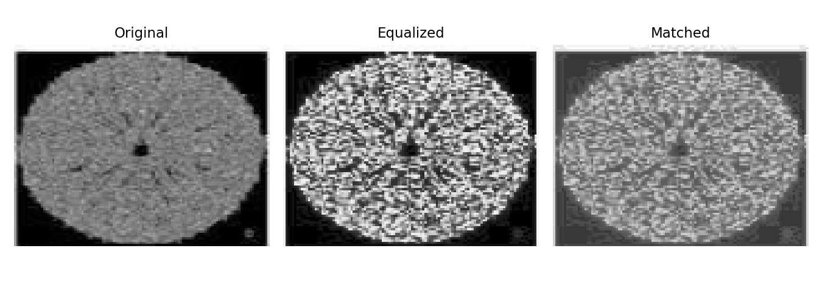
Histograms:-
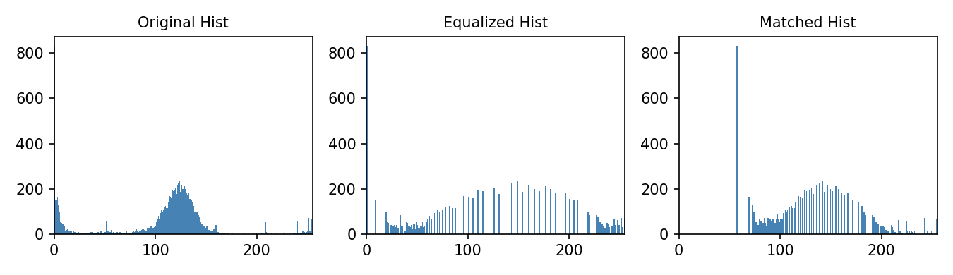
Image 3 — Histogram Equalization and Histogram Matching
Explanation
This program applies Histogram Equalization and Histogram Matching to the degraded image ex1_3.png. It then displays the original and enhanced images, compares their histograms, and calculates the mean and standard deviation to analyze changes in brightness and contrast.
1. Importing Libraries
import numpy as np
import pandas as pd
import matplotlib.pyplot as plt
NumPy is used for numerical calculations and image-array operations, Pandas is used to create the intensity mapping table for histogram matching, and Matplotlib is used to read, display, and plot the images and histograms.
2. Reading and Converting the Image
src_image = plt.imread("ex1_3.png")
The degraded image ex1_3.png is loaded into the program.
if src_image.ndim == 3:
src_image = np.dot(src_image[..., :3], [0.2989, 0.5870, 0.1140])
If the image is RGB, it is converted into a grayscale image using weighted contributions from the red, green, and blue channels.
if src_image.max() <= 1.0:
src_image = src_image * 255
If the image contains pixel values between 0 and 1, they are converted to the standard 0–255 range.
src_image = src_image.astype(np.uint8)
The image is converted into 8-bit format, where each pixel has an intensity value from 0 to 255.

3. Histogram Equalization
hist, bins = np.histogram(src_image.flatten(), 256, [0, 256])
The histogram of ex1_3.png is calculated using 256 intensity levels.
cdf = hist.cumsum()
The cumulative distribution function (CDF) is calculated from the histogram.
cdf_normalized = (cdf - cdf.min()) * 255 / (cdf.max() - cdf.min())
The CDF is normalized to the range 0–255 to create the transformation function.
cdf_normalized = cdf_normalized.astype(np.uint8)
equalized_image = cdf_normalized[src_image]
Each original pixel intensity is replaced by its corresponding transformed intensity. This produces the histogram equalized image and generally improves global contrast and detail visibility.

4. Creating the Reference Image
np.random.seed(42)
reference_image = np.random.normal(loc=128, scale=50, size=(300, 300))
A Gaussian-distributed reference image is generated with a mean of 128, standard deviation of 50, and size of 300 × 300.
reference_image = np.clip(reference_image, 0, 255).astype(np.uint8)
The pixel values are restricted to the valid 0–255 range and converted to 8-bit format. This image is used as the reference for histogram matching.

5. Calculating Histograms
src_hist, _ = np.histogram(src_image.flatten(), 256, [0, 256])
ref_hist, _ = np.histogram(reference_image.flatten(), 256, [0, 256])
The histograms of the source image and reference image are calculated.
- src_hist → histogram of ex1_3.png
- ref_hist → histogram of the reference image

6. Calculating CDFs
src_cdf = np.cumsum(src_hist).astype(np.float64)
src_cdf = src_cdf / src_cdf[-1]
The CDF of the source image is calculated and normalized between 0 and 1.
ref_cdf = np.cumsum(ref_hist).astype(np.float64)
ref_cdf = ref_cdf / ref_cdf[-1]
The same process is performed for the reference image.
The normalized CDFs are then used to establish the intensity mapping.

7. Histogram Matching
mapping = pd.Series(index=np.arange(256), dtype=np.uint8)
ref_cdf_series = pd.Series(ref_cdf)
A lookup table is created for all 256 possible intensity values.
for i in range(256):
diff = (ref_cdf_series - src_cdf[i]).abs()
mapping[i] = diff.idxmin()
For every source intensity value, the program finds the reference intensity whose CDF value is closest.
In simple terms:
This creates the mapping required for histogram matching.
mapping = mapping.values.astype(np.uint8)
matched_image = mapping[src_image]
The mapping is applied to every pixel of the original image, producing the histogram matched image.

8. Displaying the Images
The program displays three images side by side:
- Original ex1_3.png
- Histogram Equalized image
- Histogram Matched image
plt.imshow(src_image, cmap='gray', vmin=0, vmax=255)
The images are displayed in grayscale using the same intensity range, allowing their visual quality to be compared fairly.

9. Displaying the Histograms
The program displays three histograms:
- Original histogram
- Equalized histogram
- Matched histogram
The original histogram shows the initial intensity distribution. The equalized histogram shows how the intensity values have been redistributed to improve contrast, while the matched histogram shows the new distribution after matching with the Gaussian reference.

10. Mean and Standard Deviation
print(f"Original : mean={src_image.mean():.1f} std={src_image.std():.1f}")
print(f"Equalized: mean={equalized_image.mean():.1f} std={equalized_image.std():.1f}")
print(f"Matched : mean={matched_image.mean():.1f} std={matched_image.std():.1f}")
The program calculates the mean and standard deviation of all three images.
The mean represents the average brightness of the image, while the standard deviation represents the spread of intensity values and provides an indication of contrast.
A higher standard deviation generally indicates greater intensity variation and potentially higher contrast.
Code:-
import cv2
import numpy as np
import matplotlib.pyplot as plt
from skimage.exposure import match_histograms

src_image = cv2.imread("ex1_3.png", cv2.IMREAD_GRAYSCALE)

if src_image is None:
print("Image not found!")
exit()

np.random.seed(42)
reference_image = np.random.normal(loc=128, scale=50, size=(300, 300))
reference_image = np.clip(reference_image, 0, 255).astype(np.uint8)

equalized_image = cv2.equalizeHist(src_image)

matched_image = match_histograms(src_image, reference_image)
matched_image = np.uint8(np.clip(matched_image, 0, 255))

plt.figure(figsize=(15, 5))

plt.subplot(1, 3, 1)
plt.imshow(src_image, cmap='gray', vmin=0, vmax=255)
plt.title("Original")
plt.axis('off')

plt.subplot(1, 3, 2)
plt.imshow(equalized_image, cmap='gray', vmin=0, vmax=255)
plt.title("Histogram Equalized")
plt.axis('off')

plt.subplot(1, 3, 3)
plt.imshow(matched_image, cmap='gray', vmin=0, vmax=255)
plt.title("Histogram Matched")
plt.axis('off')

plt.show()
plt.figure(figsize=(15, 4))
plt.subplot(1, 3, 1)
plt.hist(src_image.ravel(), bins=256, range=(0, 255))
plt.title("Original Histogram")

plt.subplot(1, 3, 2)
plt.hist(equalized_image.ravel(), bins=256, range=(0, 255))
plt.title("Equalized Histogram")

plt.subplot(1, 3, 3)
plt.hist(matched_image.ravel(), bins=256, range=(0, 255))
plt.title("Matched Histogram")
plt.show()
print(f"Original : mean={src_image.mean():.1f} std={src_image.std():.1f}")
print(f"Equalized: mean={equalized_image.mean():.1f} std={equalized_image.std():.1f}")
print(f"Matched : mean={matched_image.mean():.1f} std={matched_image.std():.1f}")
Expected Output
After running the program, three versions of ex1_3.png will be displayed: the Original, Histogram Equalized, and Histogram Matched images. The histogram equalized image is expected to show improved global contrast and better visibility of details because its intensity values are redistributed over a wider range. The histogram matched image is expected to have an intensity distribution closer to the Gaussian reference distribution, giving a more controlled change in brightness and contrast.
A second figure will display the original, equalized, and matched histograms, showing how the intensity distribution changes after each technique. The program will also print the mean and standard deviation of all three images for numerical comparison.
Observation
After applying both enhancement techniques to ex1_3.png, the histogram equalized image shows improved global contrast because the intensity values are redistributed across a wider range. This makes image details and boundaries more visible compared with the original degraded image. However, excessive enhancement may also make noise or certain regions more prominent.
The histogram matched image adjusts the intensity distribution according to the Gaussian reference image. This provides a more controlled change in brightness and contrast and may produce a smoother and more balanced appearance than histogram equalization. The matched histogram is expected to follow the general distribution of the reference histogram.
The mean values help identify changes in average brightness, while the standard deviation indicates changes in intensity spread and contrast. Overall, both techniques enhance ex1_3.png, but the better method should be selected based on visual clarity, contrast improvement, brightness, detail visibility, and the amount of unwanted noise.
Output :-
Result:-
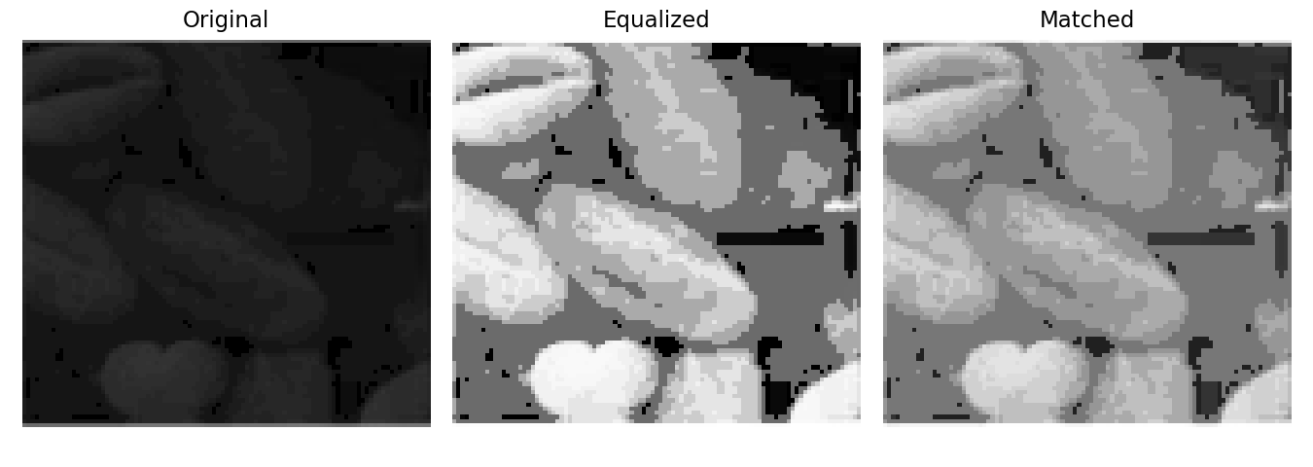
Histograms:-
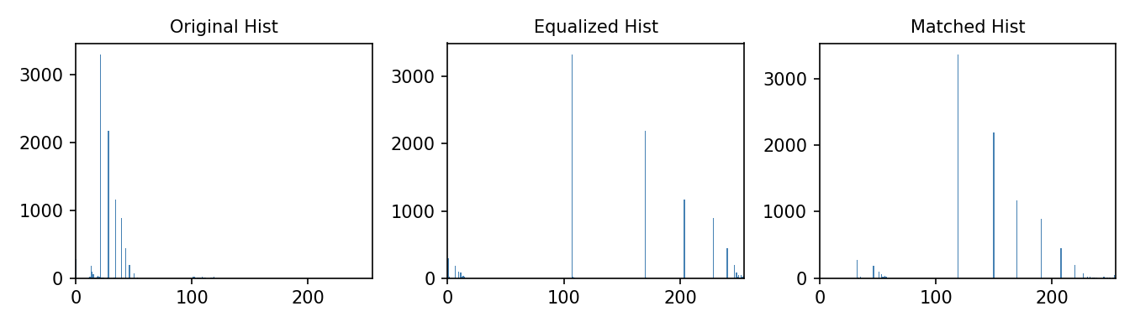

Image 4 — Night Car Photo (Histogram Equalization + Matching)
Explanation
This program applies Histogram Equalization and Histogram Matching to the degraded image ex1_4.png. It then displays the original and enhanced images, their histograms, and calculates the mean and standard deviation to compare changes in brightness and contrast.
1. Importing Libraries
import numpy as np
import pandas as pd
import matplotlib.pyplot as plt
NumPy is used for numerical calculations and image processing, Pandas is used for creating the intensity mapping table during histogram matching, and Matplotlib is used for reading, displaying, and plotting the images and histograms.
2. Reading and Converting the Image
src_image = plt.imread("ex1_4.png")
The degraded image ex1_4.png is loaded into the program.
if src_image.ndim == 3:
src_image = np.dot(src_image[..., :3], [0.2989, 0.5870, 0.1140])
If the image is RGB, it is converted into a grayscale image using weighted contributions from the red, green, and blue channels.
if src_image.max() <= 1.0:
src_image = src_image * 255
If the image uses pixel values between 0 and 1, they are converted to the standard 0–255 range.
src_image = src_image.astype(np.uint8)
The image is converted to 8-bit format, where each pixel has an intensity value between 0 and 255.

3. Histogram Equalization
hist, bins = np.histogram(src_image.flatten(), 256, [0, 256])
The histogram of ex1_4.png is calculated for all 256 possible intensity levels.
cdf = hist.cumsum()
The cumulative distribution function (CDF) is calculated from the histogram.
cdf_normalized = (cdf - cdf.min()) * 255 / (cdf.max() - cdf.min())
The CDF is normalized to the range 0–255. This produces the transformation required for histogram equalization.
cdf_normalized = cdf_normalized.astype(np.uint8)
equalized_image = cdf_normalized[src_image]
Each pixel in the original image is replaced by its corresponding transformed intensity. The resulting image is stored as equalized_image.
This process generally improves global contrast and detail visibility.

4. Creating the Reference Image
np.random.seed(42)
reference_image = np.random.normal(loc=128, scale=50, size=(300, 300))
A Gaussian-distributed reference image is generated with:
- Mean = 128
- Standard deviation = 50
- Size = 300 × 300
This reference image provides the desired intensity distribution for histogram matching.
reference_image = np.clip(reference_image, 0, 255).astype(np.uint8)
The pixel values are limited to the valid 0–255 range and converted to 8-bit format.

5. Calculating Histograms
src_hist, _ = np.histogram(src_image.flatten(), 256, [0, 256])
ref_hist, _ = np.histogram(reference_image.flatten(), 256, [0, 256])
The histograms of the source image and reference image are calculated.
- src_hist represents the histogram of ex1_4.png.
- ref_hist represents the histogram of the generated reference image.

6. Calculating CDFs
src_cdf = np.cumsum(src_hist).astype(np.float64)
src_cdf = src_cdf / src_cdf[-1]
The CDF of the source image is calculated and normalized between 0 and 1.
ref_cdf = np.cumsum(ref_hist).astype(np.float64)
ref_cdf = ref_cdf / ref_cdf[-1]
The CDF of the reference image is calculated in the same way.
The normalized CDFs are used to determine how source intensity values should be mapped to reference intensity values.

7. Histogram Matching
mapping = pd.Series(index=np.arange(256), dtype=np.uint8)
ref_cdf_series = pd.Series(ref_cdf)
A lookup table is created for all 256 possible intensity values.
for i in range(256):
diff = (ref_cdf_series - src_cdf[i]).abs()
mapping[i] = diff.idxmin()
For every intensity value in the source image, the program finds the intensity value in the reference image whose CDF is closest.
In simple terms:
mapping = mapping.values.astype(np.uint8)
matched_image = mapping[src_image]
The mapping is applied to every pixel of the original image, producing the histogram matched image.

8. Displaying the Images
The program displays three images side by side:
- Original ex1_4.png
- Histogram Equalized image
- Histogram Matched image
plt.imshow(src_image, cmap='gray', vmin=0, vmax=255)
The images are displayed in grayscale using the same 0–255 intensity range, allowing a fair visual comparison.

9. Displaying the Histograms
The program displays three histograms:
- Original histogram
- Equalized histogram
- Matched histogram
The original histogram represents the initial intensity distribution. The equalized histogram shows how the intensity values are redistributed to improve contrast, while the matched histogram shows the distribution after matching the source image with the reference image.

10. Mean and Standard Deviation
print(f"Original : mean={src_image.mean():.1f} std={src_image.std():.1f}")
print(f"Equalized: mean={equalized_image.mean():.1f} std={equalized_image.std():.1f}")
print(f"Matched : mean={matched_image.mean():.1f} std={matched_image.std():.1f}")
The program calculates the mean and standard deviation of all three images.
The mean indicates the average brightness, while the standard deviation represents the spread of intensity values and provides an indication of contrast.
A higher standard deviation generally indicates greater intensity variation and potentially higher contrast.
Code:-
import cv2
import numpy as np
import matplotlib.pyplot as plt
from skimage.exposure import match_histograms

src_image = cv2.imread("ex1_4.png", cv2.IMREAD_GRAYSCALE)

if src_image is None:
print("Image not found!")
exit()

np.random.seed(42)
reference_image = np.random.normal(loc=128, scale=50, size=(300, 300))
reference_image = np.clip(reference_image, 0, 255).astype(np.uint8)

equalized_image = cv2.equalizeHist(src_image)

matched_image = match_histograms(src_image, reference_image)
matched_image = np.uint8(np.clip(matched_image, 0, 255))

plt.figure(figsize=(15, 5))

plt.subplot(1, 3, 1)
plt.imshow(src_image, cmap='gray', vmin=0, vmax=255)
plt.title("Original")
plt.axis('off')

plt.subplot(1, 3, 2)
plt.imshow(equalized_image, cmap='gray', vmin=0, vmax=255)
plt.title("Histogram Equalized")
plt.axis('off')

plt.subplot(1, 3, 3)
plt.imshow(matched_image, cmap='gray', vmin=0, vmax=255)
plt.title("Histogram Matched")
plt.axis('off')

plt.show()

plt.figure(figsize=(15, 4))

plt.subplot(1, 3, 1)
plt.hist(src_image.ravel(), bins=256, range=(0, 255))
plt.title("Original Histogram")

plt.subplot(1, 3, 2)
plt.hist(equalized_image.ravel(), bins=256, range=(0, 255))
plt.title("Equalized Histogram")

plt.subplot(1, 3, 3)
plt.hist(matched_image.ravel(), bins=256, range=(0, 255))
plt.title("Matched Histogram")

plt.show()

print(f"Original : mean={src_image.mean():.1f} std={src_image.std():.1f}")
print(f"Equalized: mean={equalized_image.mean():.1f} std={equalized_image.std():.1f}")
print(f"Matched : mean={matched_image.mean():.1f} std={matched_image.std():.1f}")
Expected Output
After running the program, three versions of ex1_4.png will be displayed: Original, Histogram Equalized, and Histogram Matched. The histogram equalized image is expected to show improved global contrast and better visibility of image details because the intensity values are redistributed across a wider range. The histogram matched image is expected to have an intensity distribution closer to the Gaussian reference image, resulting in a more controlled change in brightness and contrast.
A second figure will display the original, equalized, and matched histograms, showing how the intensity distribution changes after each technique. The program will also print the mean and standard deviation of all three images for numerical comparison.
Observation
After applying both techniques to ex1_4.png, the histogram equalized image shows improved global contrast by spreading the pixel intensity values over a wider range. This makes image structures, edges, and details more visible than in the original degraded image. However, if the original image contains noise, equalization may also make some unwanted variations more noticeable.
The histogram matched image adjusts the intensity distribution according to the Gaussian reference image. This provides a more controlled change in brightness and contrast and can give the image a smoother and more balanced appearance. Its histogram follows the general distribution of the reference histogram.
The changes in mean show how the average brightness is affected, while the changes in standard deviation indicate changes in intensity spread and contrast. Overall, both techniques improve the visual quality of ex1_4.png; however, the better method should be determined by comparing contrast, detail visibility, brightness, noise, and overall visual clarity.

Output :-
Result:-
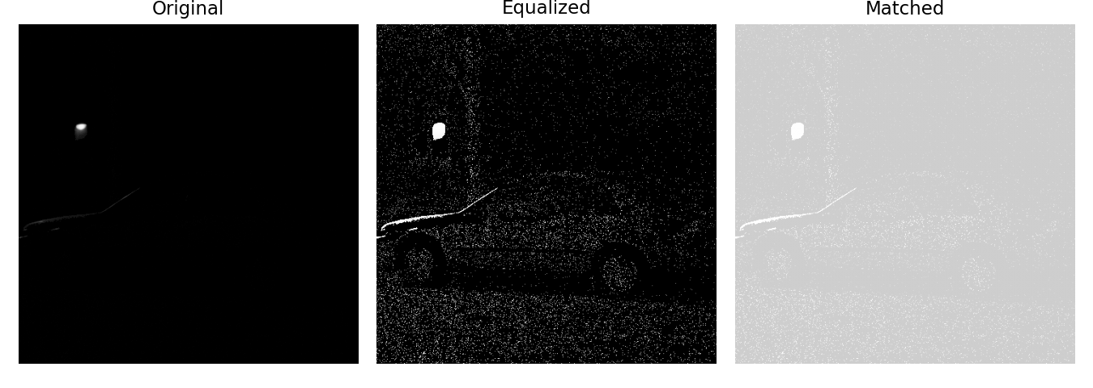
Histograms:-
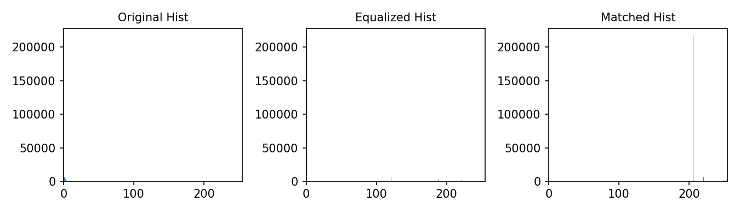

Image 5 — Histogram Equalization and Histogram Matching
Explanation
This program applies Histogram Equalization and Histogram Matching to the degraded image ex1_5.png. It then displays the original and enhanced images, compares their histograms, and calculates the mean and standard deviation to analyze changes in brightness and contrast.
1. Importing Libraries
import numpy as np
import pandas as pd
import matplotlib.pyplot as plt
NumPy is used for numerical calculations and image processing, Pandas is used to create the intensity mapping table for histogram matching, and Matplotlib is used to read, display, and plot the images and histograms.
2. Reading and Converting the Image
src_image = plt.imread("ex1_5.png")
The degraded image ex1_5.png is loaded into the program.
if src_image.ndim == 3:
src_image = np.dot(src_image[..., :3], [0.2989, 0.5870, 0.1140])
If the image is RGB, it is converted into grayscale using weighted contributions from the red, green, and blue channels.
if src_image.max() <= 1.0:
src_image = src_image * 255
If the image contains pixel values between 0 and 1, they are converted to the standard 0–255 intensity range.
src_image = src_image.astype(np.uint8)
The image is converted into 8-bit format, where each pixel has an intensity value from 0 to 255.

3. Histogram Equalization
hist, bins = np.histogram(src_image.flatten(), 256, [0, 256])
The histogram of ex1_5.png is calculated using 256 intensity levels.
cdf = hist.cumsum()
The Cumulative Distribution Function (CDF) is calculated from the histogram.
cdf_normalized = (cdf - cdf.min()) * 255 / (cdf.max() - cdf.min())
The CDF is normalized to the range 0–255. This creates the transformation function used for histogram equalization.
cdf_normalized = cdf_normalized.astype(np.uint8)
equalized_image = cdf_normalized[src_image]
Each original intensity value is replaced by its corresponding transformed value. The resulting image is stored in equalized_image.
This process improves global contrast by redistributing the pixel intensity values.

4. Creating the Reference Image
np.random.seed(42)
reference_image = np.random.normal(loc=128, scale=50, size=(300, 300))
A Gaussian-distributed reference image is generated with:
- Mean = 128
- Standard deviation = 50
- Size = 300 × 300
This reference image provides the target intensity distribution for histogram matching.
reference_image = np.clip(reference_image, 0, 255).astype(np.uint8)
The intensity values are restricted to the valid 0–255 range and converted into 8-bit format.

5. Calculating Histograms
src_hist, _ = np.histogram(src_image.flatten(), 256, [0, 256])
ref_hist, _ = np.histogram(reference_image.flatten(), 256, [0, 256])
The histograms of both images are calculated.
- src_hist → histogram of the degraded image.
- ref_hist → histogram of the reference image.
These histograms are required for histogram matching.

6. Calculating CDFs
src_cdf = np.cumsum(src_hist).astype(np.float64)
src_cdf = src_cdf / src_cdf[-1]
The CDF of the source image is calculated and normalized between 0 and 1.
ref_cdf = np.cumsum(ref_hist).astype(np.float64)
ref_cdf = ref_cdf / ref_cdf[-1]
The CDF of the reference image is calculated and normalized in the same way.
The two CDFs are then used to find the relationship between source and reference intensities.

7. Histogram Matching
mapping = pd.Series(index=np.arange(256), dtype=np.uint8)
ref_cdf_series = pd.Series(ref_cdf)
A lookup table is created for all 256 possible intensity values.
for i in range(256):
diff = (ref_cdf_series - src_cdf[i]).abs()
mapping[i] = diff.idxmin()
For every intensity value in the source image, the program finds the reference intensity whose CDF is closest.
In simple terms:
This creates the intensity mapping required for histogram matching.
mapping = mapping.values.astype(np.uint8)
matched_image = mapping[src_image]
The mapping is applied to every pixel of the original image, producing the histogram matched image.

8. Displaying the Images
The program displays three images side by side:
- Original
- Histogram Equalized
- Histogram Matched
plt.imshow(src_image, cmap='gray', vmin=0, vmax=255)
The images are displayed in grayscale using the same 0–255 range, which makes visual comparison easier.

9. Displaying the Histograms
The program displays three histograms:
- Original histogram
- Equalized histogram
- Matched histogram
The original histogram shows the initial intensity distribution. The equalized histogram shows how the intensity values are redistributed to improve contrast, while the matched histogram shows the distribution obtained after matching the image with the Gaussian reference.

10. Mean and Standard Deviation
print(f"Original : mean={src_image.mean():.1f} std={src_image.std():.1f}")
print(f"Equalized: mean={equalized_image.mean():.1f} std={equalized_image.std():.1f}")
print(f"Matched : mean={matched_image.mean():.1f} std={matched_image.std():.1f}")
The program calculates the mean and standard deviation of the original and enhanced images.
The mean represents the average brightness of the image, while the standard deviation represents the spread of intensity values and gives an indication of contrast.
A higher standard deviation generally means greater intensity variation and potentially higher contrast.
Code:-
import cv2
import numpy as np
import matplotlib.pyplot as plt
from skimage.exposure import match_histograms

src_image = cv2.imread("ex1_5.png", cv2.IMREAD_GRAYSCALE)

if src_image is None:
print("Image not found!")
exit()

np.random.seed(42)
reference_image = np.random.normal(loc=128, scale=50, size=(300, 300))
reference_image = np.clip(reference_image, 0, 255).astype(np.uint8)

equalized_image = cv2.equalizeHist(src_image)

matched_image = match_histograms(src_image, reference_image)
matched_image = np.uint8(np.clip(matched_image, 0, 255))

plt.figure(figsize=(15, 5))

plt.subplot(1, 3, 1)
plt.imshow(src_image, cmap='gray', vmin=0, vmax=255)
plt.title("Original")
plt.axis('off')

plt.subplot(1, 3, 2)
plt.imshow(equalized_image, cmap='gray', vmin=0, vmax=255)
plt.title("Histogram Equalized")
plt.axis('off')

plt.subplot(1, 3, 3)
plt.imshow(matched_image, cmap='gray', vmin=0, vmax=255)
plt.title("Histogram Matched")
plt.axis('off')

plt.show()

plt.figure(figsize=(15, 4))

plt.subplot(1, 3, 1)
plt.hist(src_image.ravel(), bins=256, range=(0, 255))
plt.title("Original Histogram")

plt.subplot(1, 3, 2)
plt.hist(equalized_image.ravel(), bins=256, range=(0, 255))
plt.title("Equalized Histogram")

plt.subplot(1, 3, 3)
plt.hist(matched_image.ravel(), bins=256, range=(0, 255))
plt.title("Matched Histogram")

plt.show()

print(f"Original : mean={src_image.mean():.1f} std={src_image.std():.1f}")
print(f"Equalized: mean={equalized_image.mean():.1f} std={equalized_image.std():.1f}")
print(f"Matched : mean={matched_image.mean():.1f} std={matched_image.std():.1f}")
Expected Output
After running the program, three versions of ex1_5.png will be displayed: Original, Histogram Equalized, and Histogram Matched. The histogram equalized image is expected to have improved global contrast because the intensity values are redistributed across a wider range, making details and edges more visible. The histogram matched image is expected to have an intensity distribution closer to the Gaussian reference image, producing a more controlled change in brightness and contrast.
A second figure will display the original, equalized, and matched histograms, showing how the intensity distribution changes after each technique. The program will also print the mean and standard deviation of all three images for numerical comparison.
Observation
After applying both techniques to ex1_5.png, the histogram equalized image shows improved global contrast as the pixel intensities are distributed over a wider range. This makes image details, edges, and object boundaries more visible compared with the original degraded image. However, if noise is present, histogram equalization may also make it more noticeable.
The histogram matched image modifies the intensity distribution according to the Gaussian reference image. This provides a more controlled change in brightness and contrast and can produce a smoother and more balanced appearance. Its histogram follows the general distribution of the selected reference histogram.
The mean values indicate changes in average brightness, while the standard deviation indicates changes in intensity spread and contrast. Overall, both methods improve the visual quality of ex1_5.png. The better method should be determined by comparing contrast, detail visibility, brightness, noise, and overall clarity of the two enhanced results.

Output :-
Result:-
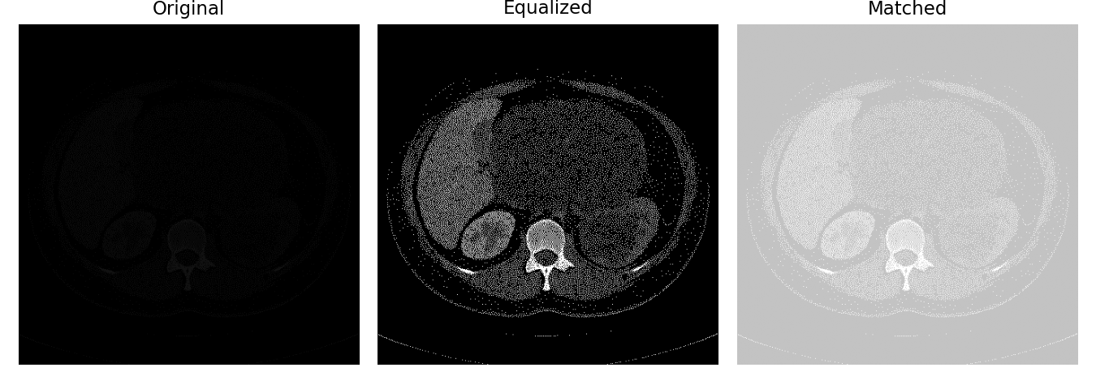
Histograms:-
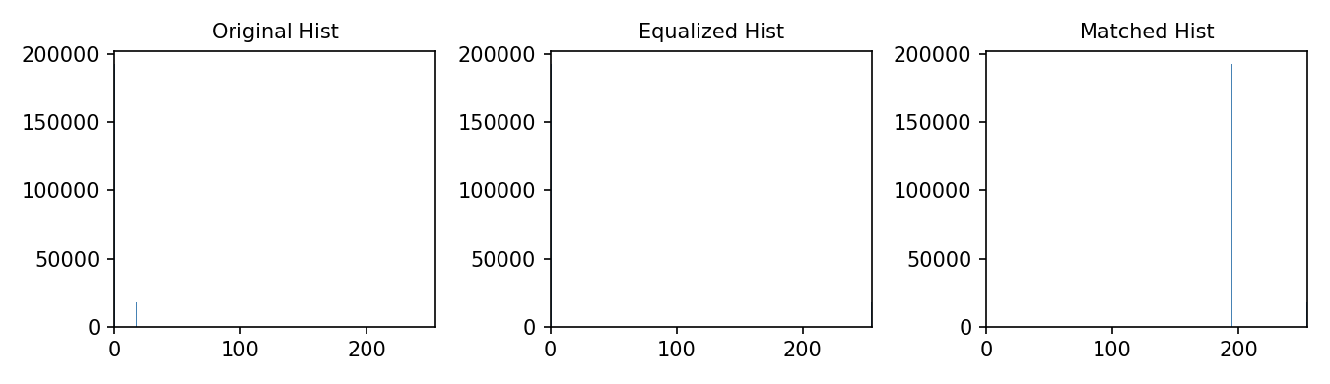
Conclusion :-
In this experiment, the same set of degraded images from OPE7 was enhanced using Histogram Equalization and Histogram Matching. Histogram Equalization improved the overall contrast by spreading the pixel intensity values over a wider range, which made hidden details, edges, and object boundaries more visible. However, in some images, it could produce excessive contrast and make noise more noticeable. Histogram Matching provided more controlled enhancement by adjusting the intensity distribution according to the selected Gaussian reference histogram, resulting in a smoother and more balanced appearance.
Overall, Histogram Equalization was more effective for images where strong global contrast improvement was required, while Histogram Matching was more suitable when a controlled brightness and contrast distribution was desired. The performance of both techniques depended on the characteristics of each degraded image. Therefore, there is no single method that is best for every image; the better approach is the one that provides the best balance between contrast, clarity, brightness, detail visibility, and noise suppression for a particular image.
Github link :-

